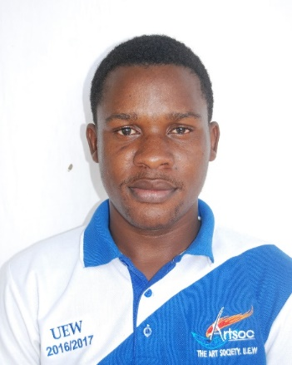
Summary
A trained teacher in the field of Art Education, equiped with teaching Graphic Design, Ceramics and other art related course at any academic level. Also a Graphic Designer with specializing in Still Graphics, Motion Graphics, Web Design, 3D Designs, Digital Painting and Video Editing. Experienced with numerous software such as Microsoft Suit, Maxon Cinema 4D, Adobe Illustrator, Adobe InDesign, Adobe Photoshop, Adobe Muse, Adobe After Effects, and Adobe Premier Pro. In addition, I have experience with Photography (including studio works and outdoor works and Videography. Strong background in project management, team work and customer relations.

Skills Highlight
- Project Management  - Strong Decision Maker  - Complex Problem Solver | - Creative Designer  - Innovative  - Service-focused  - Creative Cinematographer

Work Experience
Graphic Designer - 05/2014 till 2020
Grace Ventures, Dabala
- Design Simple Responsive Websites for Clients.
- Design Posters, Banners, and other still Graphics for Clients.
- Text Formatting and Layout Designing

Teacher - 09/2017 To 05/2019
North Gate Baptist School, Winneba
- Preparing of Teaching Aids
- Instructing Practical Activities
- Organizing and implementing Test Items
- Teaching Visual and Creative Art

Intern - Teacher - 09/2019 To 12/2019
Dabala Senior High Technical School, Dabala
- Preparing of Teaching Aids
- Instructing Practical Activities
- Organizing and implementing Test Items
- Teaching Graphic Design

Service Personnel - Teacher - 09/2020 To 09/2021
Dabala Senior High Technical School, Dabala
- Preparing of Teaching Aids
- Instructing Practical Activities
- Organizing and implementing Test Items
- Teaching Graphic Design

PASCAL DAVID
ANJORIN

Contact
Address:
Post Office Box 09,
Dabala, Volta Region,
Ghana

Phone:
+233 (0)54 971 6515
+233 (0)27 988 1644

Email:
Salomey99.pd@gmail.com

Languages
English
Ewe
Fanti
French
Twi

Marital Status
Single

Religion
Christianity – Charismatic
(Global Evangelical Church)

Education
Bachelor of Arts: Art Education - 2020
University of Education, Winneba, Winneba

High School: Visual Art – 2014
Kwegyir Aggrey Senior High Technical School, Anomabo

Certifications
First Degree: University of Education, Winneba, Ghana
Nov/Dec: West Africa Examination Council, Ghana (Private)
WASSCE: West Africa Examination Council, Ghana

Interest and Hobby
- Computer Games  - Lawn Tennis  - Designing  - Photography | - Movies  - Rap and Gospel Music  - Acting  - Playing Piano

References
Dr. Eric Kwame Edjaku
Lecturer
Fashion and Textiles Department
University of Cape Coast
+233 (0)24 337 1268

Dr. Ernest Okae-Anti
Lecturer
Art Education Department
University of Education, Winneba
+233 (0)24 472 1166

Dr. Victor Teye
Lecturer
Graphic Design Department
University of Education, Winneba
+233 (0)24 472 1166

